

Calculation sub-system test plan

Propulsion system simulation

Fangzhou chen Jiacong li Marco Hoogesteger Martijn Crombeen

*Organisation: Solar Boat Sealander*

*Client: Mr. R. Eijlers*

*Tutor: Mr. W. Haak*

*Date: 27-10-2020*

2020

Table of content

1. Aim & Hypothesis 2

1.1. Aim 2

1.2. Hypothesis 2

2. Variables 2

2.1. Inputs 2

2.2. Outputs 2

3. Tools 3

4. Method 3

4.1. Steps 3

5. Expected results 3

6. Conclusion 3

# Aim & Hypothesis

## Aim

The aim of this test is to verify that the calculation chain of the propulsion system of the Solar boat works.

## Hypothesis

The calculation chain will work.

# Variables

These are the constants and variables that will be used during the test.

|  |  |
| --- | --- |
| Constants simulation | Keep constant at... |
| Ambient temperature | Standard indoor temperature with lower and upper limits (20 ℃ ± 5℃). |
| Battery level computer | Constant power source. |
| All input variables | Real positive numbers & ISO-notation. |

## Inputs

The limits stated are the limits of the real world. If values out of this range are entered, the outputs will be unreliable.

|  |  |
| --- | --- |
| Inputs | Value |
| Boat speed [m/s] | 0-8.33m/s |

## Outputs

These are the outputs that will be monitored and will be used to see variations or changes in the system.

|  |  |
| --- | --- |
| Outputs | Value |
| Power input [W] | Indicator between 0 & 6000 |
| Power output [W] | Indicator between 0 & 4100 |
| Thrust [N] | Indicator between 0 & 500 |
| Power loss [W] | Indicator between 0-2000 |
| Efficiency [%] | Indicator between 0-100 |

# Tools

|  |  |
| --- | --- |
| Testing tools | Demand |
| Computer | Windows 10 compatible |
| Excel | Newest version |
| Keyboard | No limit |
| Mouse | No limit |
| Calculator | Basic calculator |
| Pen & Paper | Basic pen & paper |

# Method

This section consists of actions that need to be performed during the test to conclude a result. The conditions of the constants stated in chapter “2. Variables” have to be met before executing the simulation. To execute the simulation, follow the steps stated in “4.1. Steps”.

## Steps

1. Set up computer and load in simulation.
2. Set all the properties setting values.
3. Insert 6 different boat speeds in steps.
4. Run the simulation for every input.
5. Note the output values for every input.
6. Compare the simulation output with real data.

# Expected results

The expected results of the outputs are as followed.

The following list give the real data of the real solar boat, 6 simulation outputs have average deviation ratio less than 10% compared with real data.

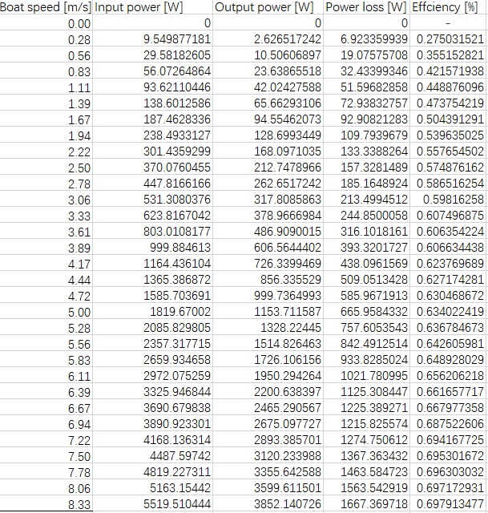

# Conclusion

When the outputs of the calculation chain do not deviate more than 10% of the measured values, we state that the simulation passes the test.

When the outputs of the calculation chain deviate more than this range, we state that the simulation failed the test.